IEC 62443
- The ISA/IEC 62443 is a series of standards developed by the ISA99 committee and adopted by the International Electrotechnical Commission (IEC).
- It helps organizations to reduce both the risk of system failure and the exposure to cyber threats.
- Main security objectives of IEC 62443 are in-depth defense, taking low-level requirements and extending security to other areas, from manufacturers to operators, to consider different attack surfaces.

- Scope of the application includes everything from the final IT system to the different subsystems and equipment involved.
- The two most important aspects / definitions of the measures found throughout the legislation are:
- Security zones: A group of physical / logical assets that share common security requirements.
A zone clearly delimits the whole by defining a logical or physical border that separates internal and external parts.
- Gateways: These are communication paths between two security zones.
They provide the security features that allow two zones to communicate securely.
All communication between different areas must be performed through a gateway.

- ISA/ IEC 62443 consists of 14 documents divided into four groups:
General
Policies and Procedures
System
Component.
- General 62443-1:
  - Groups together documents covering general concepts, terminology, and methods.
  - It defines a glossary.

- Policies & procedures 62443-2:
  - Specifies structural measures and is aimed at operators and maintainers of automation solutions.
  - It also contains recommendations for corrections and updates to system components, in compliance with the specific characteristics of critical industrial infrastructure (IEC-62443-2-3).

- System 62443-3:
  - Focuses on operational security methods for IACSs (Industrial Automation and Control Systems.
  - It provides an up-to-date assessment of the various cybersecurity tools, describes the method and resources for structuring their architecture into zones and channels, and provides an inventory of cyberattack protection techniques.
  - In this way, it provides a means of segmenting IACSs into zones, based on equipment criticality levels (62443-3-2).
  - These zones can communicate with one another – whether by USB key, network cable or VPN link.

- Component 62443-4:
  - Intended for manufacturers of command and control solutions: PLCs, monitoring systems, engineering stations and other switching equipment.
  - This part describes the safety requirements for such equipment and sets out best practice for product development.

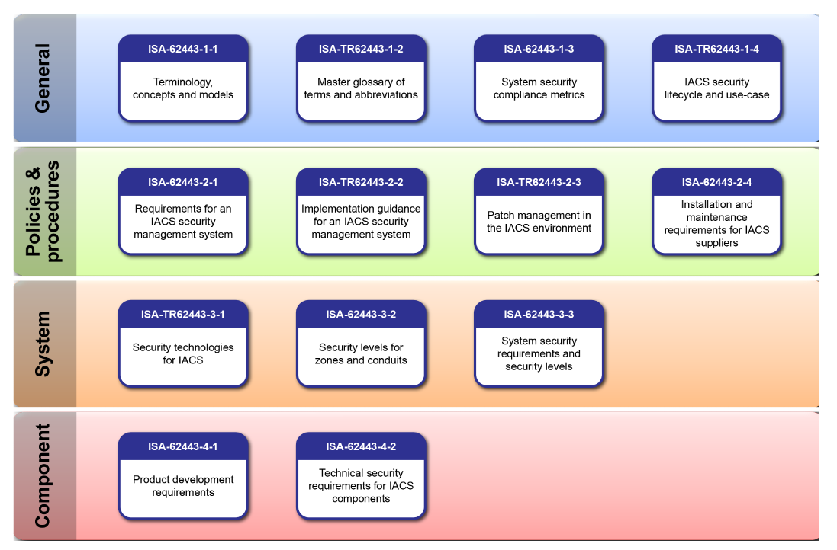
- The seven fundamental requirements of the IEC 62443 standard:
  - Identify and authenticate all users (people, software processes and devices) before authorizing access to a system.
  - control use (enforce the privileges assigned to an authenticated user).
  - ensure the integrity of data, software, and equipment.
  - ensure the confidentiality of information in data flows, and in data storage spaces.
  - restrict unnecessary data flows.
  - respond to attacks by informing the competent authority in a timely manner.
  - and ensure that the system is resilient against a DDoS attack.

- IEC 62443 describes different levels of maturity for processes and technical requirements.
- The maturity levels for processes are based on the maturity levels from the CMMI framework.
- Maturity Level
Based on CMMI, IEC 62443 describes different maturity levels for processes through so-called "maturity levels".
The maturity levels are described as follows:
- Maturity Level 1 - Initial: Product suppliers usually carry out product development ad hoc and often undocumented (or not fully documented).
- Maturity Level 2 - Managed: The product supplier can manage the development of a product according to written guidelines.
It must be demonstrated that the personnel who carry out the process have the appropriate expertise, are trained and/or follow written procedures.
The processes are repeatable.
- Maturity Level 3 - Defined (practiced): The process is repeatable throughout the supplier's organization.
The processes have been practiced and there is evidence that this has been done.
- Maturity Level 4 – (Improving): Product suppliers use appropriate process metrics to monitor the effectiveness and performance of the process and demonstrate continuous improvement in these areas.
- Security Level
Technical requirements for systems (IEC 62443-3-3) and products (IEC 62443-4-2) are evaluated in the standard by four so-called Security Levels (SL).
The different levels indicate the resistance against different classes of attackers.
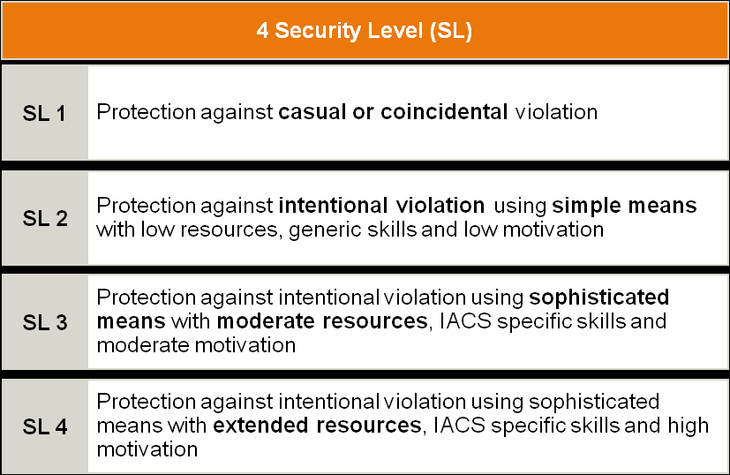

- There are ISA/IEC 62443 Cybersecurity Certification Programs:

- Certificate 1: ISA/IEC 62443 Cybersecurity Fundamentals Specialist.
- Certificate 2: ISA/IEC 62443 Cybersecurity Risk Assessment Specialist.
- Certificate 3: ISA/IEC 62443 Cybersecurity Design Specialist.
- Certificate 4: ISA/IEC 62443 Cybersecurity Maintenance Specialist.
- ISA/IEC 62443 Cybersecurity Expert: Individuals who achieve Certificates 1, 2, 3, and 4 are designated as ISA/IEC 62443 Cybersecurity Experts.
Link for the certification requirements and training course:
https://www.isa.org/training-and-certification/isa-certification/isa99iec-62443/isa99iec-62443-cybersecurity-certificate-programs

REFERENCES
https://www.infineon.com/cms/en/product/promopages/iec62443/#applications
https://cyberstartupobservatory.com/practical-guidelines-for-conducting-iec-62443-assessments-using-radiflow-products/

